

|  |
| --- |
| Prototype1 |
| 06/10/17 17:00 |
| **Author:** John Doe  **File name:** Prototype1.vp  **Version** 1.0 |

|  |
| --- |
| Site Map |
|  |

|  |
| --- |
|  |

01. Site Map / Prototype1 

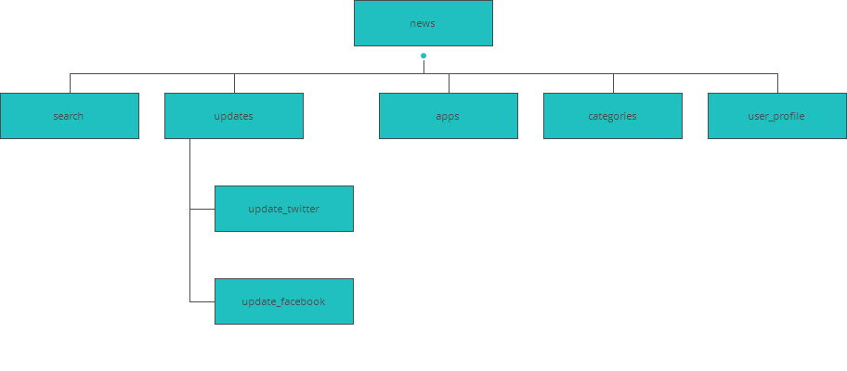

|  |
| --- |
| Screens |
|  |

|  |
| --- |
|  |

02. Screens / Prototype1 

updates

|  |
| --- |
|  |

Interactions

|  |  |
| --- | --- |
| 1 | **on Click:** goes to 'update_twitter' with effect: slide left 🡪 |
| 2 | **on Click:** goes to 'update_facebook' with effect: slide left 🡪 |
| 3 | **on Click:** goes to 'search' with effect: slide left 🡪 |
| 4 | **on Click:** goes to 'apps' with effect: slide right 🡪 |
| 5 | **on Click:** goes to 'categories' with effect: slide right 🡪 |
| 6 | **on Click:** goes to 'news' with effect: slide right 🡪 |
| 7 | **on Click:** goes to 'user_profile' with effect: slide up 🡪 |

02. Screens / Prototype1 

update_twitter

|  |
| --- |
|  |

Interactions

|  |  |
| --- | --- |
| 8 | **on Click:** goes to 'updates' with effect: slide right 🡪 |
| 9 | **on Click:** goes to 'search' with effect: slide left 🡪 |
| 10 | **on Click:** goes to 'updates' with effect: slide left 🡪 |
| 11 | **on Click:** goes to 'apps' with effect: slide right 🡪 |
| 12 | **on Click:** goes to 'categories' with effect: slide right 🡪 |
| 13 | **on Click:** goes to 'news' with effect: slide right 🡪 |
| 14 | **on Click:** goes to 'user_profile' with effect: slide up 🡪 |

02. Screens / Prototype1 

user_profile

|  |
| --- |
|  |

02. Screens / Prototype1 

news

|  |
| --- |
|  |

Interactions

|  |  |
| --- | --- |
| 15 | **on Click:** goes to 'search' with effect: slide left 🡪 |
| 16 | **on Click:** goes to 'updates' with effect: slide left 🡪 |
| 17 | **on Click:** goes to 'apps' with effect: slide left 🡪 |
| 18 | **on Click:** goes to 'categories' with effect: slide left 🡪 |
| 19 | **on Click:** goes to 'user_profile' with effect: slide up 🡪 |

02. Screens / Prototype1 

categories

|  |
| --- |
|  |

Interactions

|  |  |
| --- | --- |
| 20 | **on Click:** goes to 'search' with effect: slide left 🡪 |
| 21 | **on Click:** goes to 'updates' with effect: slide left 🡪 |
| 22 | **on Click:** goes to 'apps' with effect: slide left 🡪 |
| 23 | **on Click:** goes to 'news' with effect: slide right 🡪 |
| 24 | **on Click:** goes to 'user_profile' with effect: slide up 🡪 |

02. Screens / Prototype1 

apps

|  |
| --- |
|  |

Interactions

|  |  |
| --- | --- |
| 25 | **on Click:** goes to 'user_profile' with effect: slide up 🡪 |
| 26 | **on Click:** goes to 'search' with effect: slide left 🡪 |
| 27 | **on Click:** goes to 'updates' with effect: slide left 🡪 |
| 28 | **on Click:** goes to 'categories' with effect: slide right 🡪 |
| 29 | **on Click:** goes to 'news' with effect: slide right 🡪 |

02. Screens / Prototype1 

search

|  |
| --- |
|  |

Interactions

|  |  |
| --- | --- |
| 30 | **on Click:** goes to 'updates' with effect: slide right 🡪 |
| 31 | **on Click:** goes to 'apps' with effect: slide right 🡪 |
| 32 | **on Click:** goes to 'categories' with effect: slide right 🡪 |
| 33 | **on Click:** goes to 'news' with effect: slide right 🡪 |
| 34 | **on Click:** goes to 'user_profile' with effect: slide up 🡪 |

02. Screens / Prototype1 

update_facebook

|  |
| --- |
|  |

Interactions

|  |  |
| --- | --- |
| 35 | **on Click:** goes to 'updates' with effect: slide right 🡪 |
| 36 | **on Click:** goes to 'user_profile' with effect: slide up 🡪 |
| 37 | **on Click:** goes to 'search' with effect: slide left 🡪 |
| 38 | **on Click:** goes to 'updates' with effect: slide left 🡪 |
| 39 | **on Click:** goes to 'apps' with effect: slide right 🡪 |
| 40 | **on Click:** goes to 'categories' with effect: slide right 🡪 |
| 41 | **on Click:** goes to 'news' with effect: slide right 🡪 |

|  |
| --- |
| Templates |
|  |

|  |
| --- |
|  |

03. Templates / Prototype1 

Template 1

|  |
| --- |
|  |

|  |
| --- |
| Scenarios |
|  |

|  |
| --- |
|  |

04. Scenarios / Prototype1 

default

|  |
| --- |
|  |